 | You ain’t said nothin’ till you played the blues… |  | April 2019
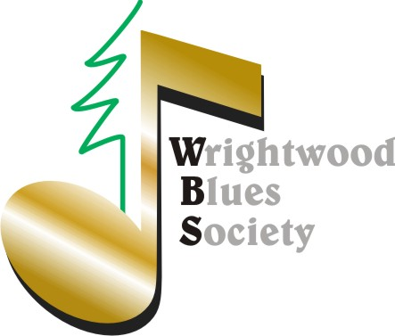 |  | 3 Free Music Concerts for Members Only | SAVE WBS DATES: Members Only Events  *June 29 Greg Jones Retirement Party  *October 26 Masquerade P Party  *December 21 Xmas Party

$1,000 to Paradise! Sunday April 14th 3PM WGT
Thank You for all the tremendous support at the March 31st event. What a wonderful world in which our little town gives to another little town some 500 miles away. The Boys and Girls club have expressed many thanks to Gayle & Tommy Dowling (Producers) CenterStage productions and WBS for stepping up to help. Some WBS members (you know who you are) donated even though not able to attend the event. We covered all production cost and sent $1,000 to Paradise.  And how cool that Brandon Roque representing Assemblyman Tom Lackey used the Paradise event as an opportunity to honor our WBS 2019 scholarship recipients with an awesome certificate and words of encouragement. Cheers to Gayle & Company, the George Keen band, John Burcher, Colonel Gary and others for excellent musical performances.  WBS has spearheaded a new Wrightwood Wall of Fame project to be unveiled at the April 14th event, Thanks in part to a grant from http://onetownatatime.org |  | April 14 Wrightwood’s Got Talent (*WGT) And now the 2019 Scholarship Journey Begins! April 14th, 12 acts take the stage with everything from comedy to dance to solo and band performances. A Panel of Judges will vote up or down which acts will move on to the September Finals Show. There will also be surprise performances from WBS members/supporters as icing on the cake.  Each act will receive immediate feedback from at least one judge following each performance. Acts moving on to the Finals Show will be offered complimentary mentoring thanks to the Wrightwood Classical Concert Series**.  The final show in September will be judged by WBS Gold Members. The Scholarship winner will receive $1,000, a paid performance spot in Music in Pines series and CenterStage promotional opportunities! Support WGT by donating here  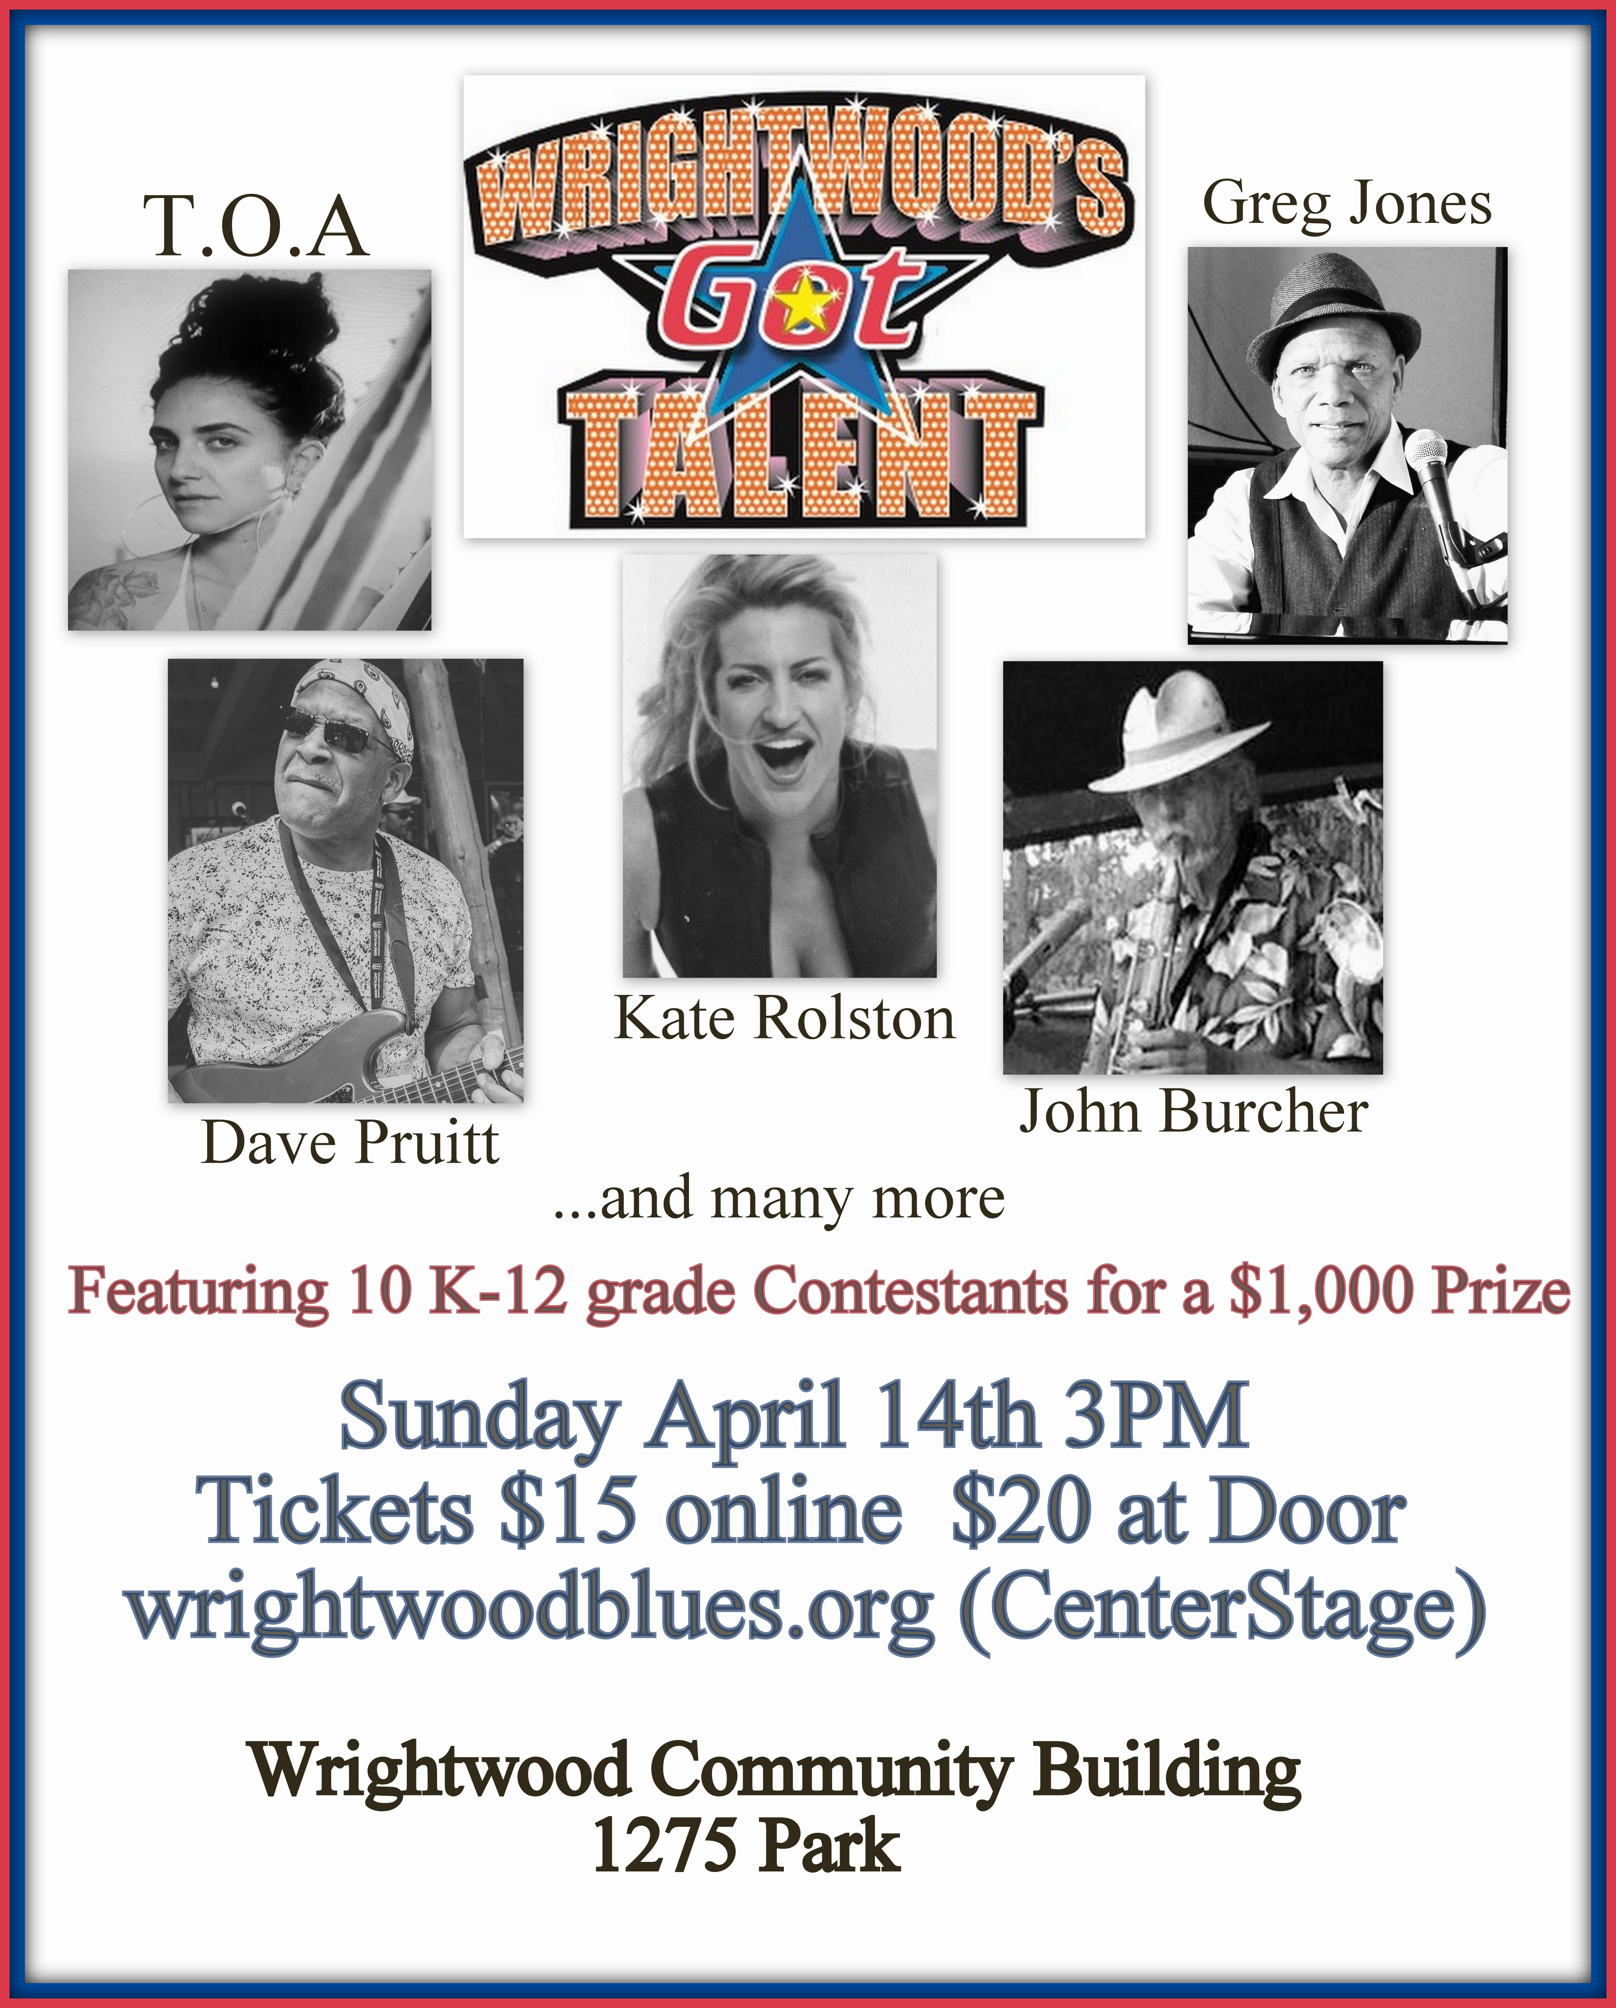 | *WGT Acts moving on to the Finals Show may receive summer mentoring compliments of the:  **Wrightwood Classical Concert Series  Support WGT by purchasing an advanced ticket for: “An Evening of Piano  April 28, 2019 3:30 PM  Wrightwood Community United Methodist Church  1543 Barbara St, Wrightwood, CA  To purchase tickets:  USPS: check payable to  Joyce Wonderly, PO Box 354, Wrightwood, 92397.  Email: joyce@keyboardart.com  Pay via PayPal

