 | You ain’t said nothin’ till you played the blues… |  | February 2019
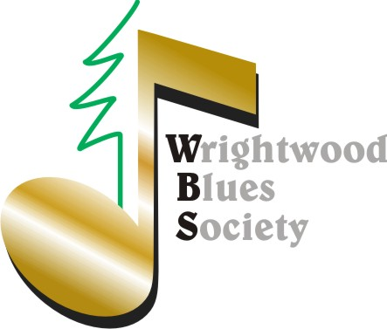 |  |  | In case you missed it (Click it): "Big T" Video Tribute  CenterStage Series 1 Min Video

SAVE THE DATES SAVE THE DATES SAVE THE DATES
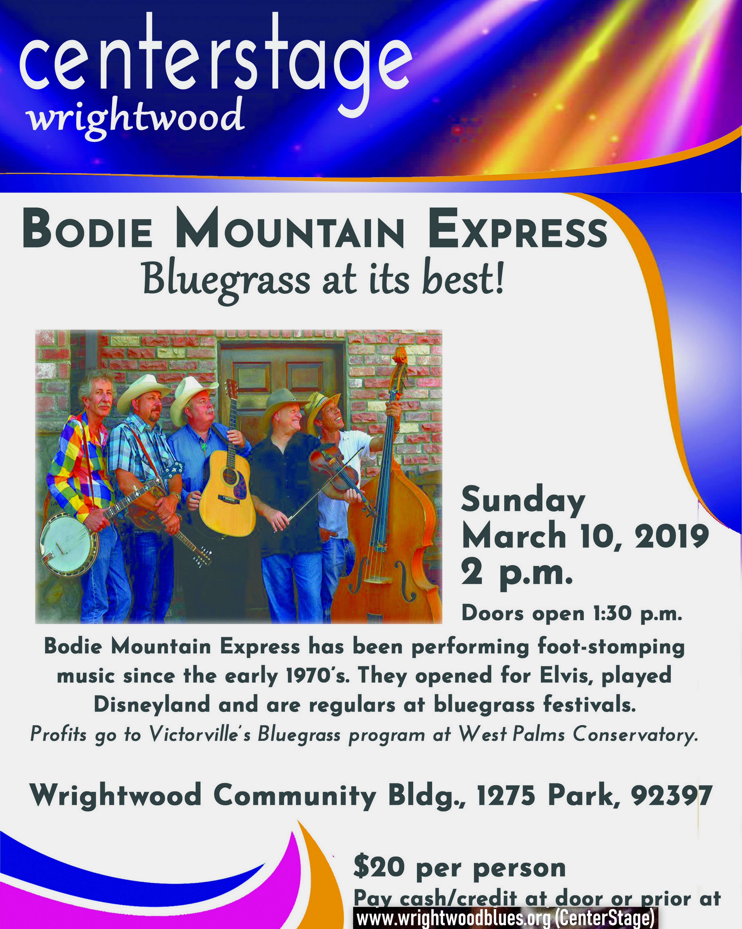March 10  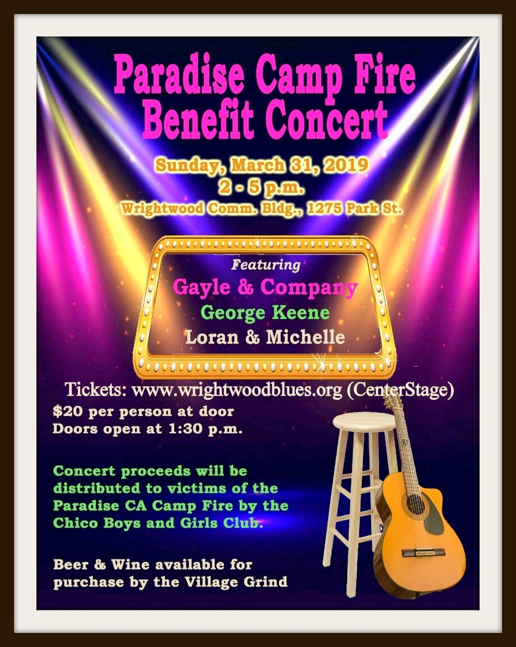March 31  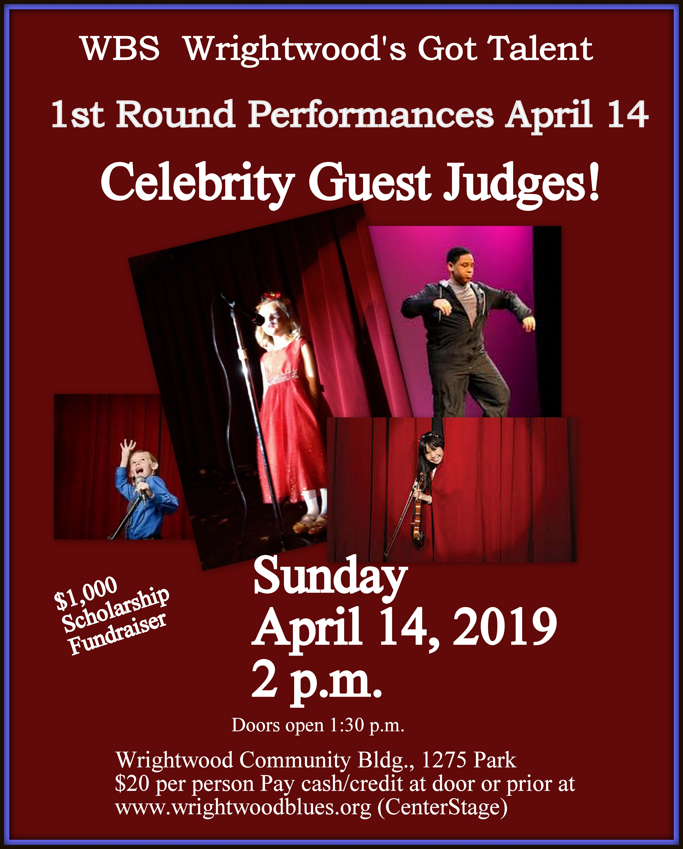April 14 |  | 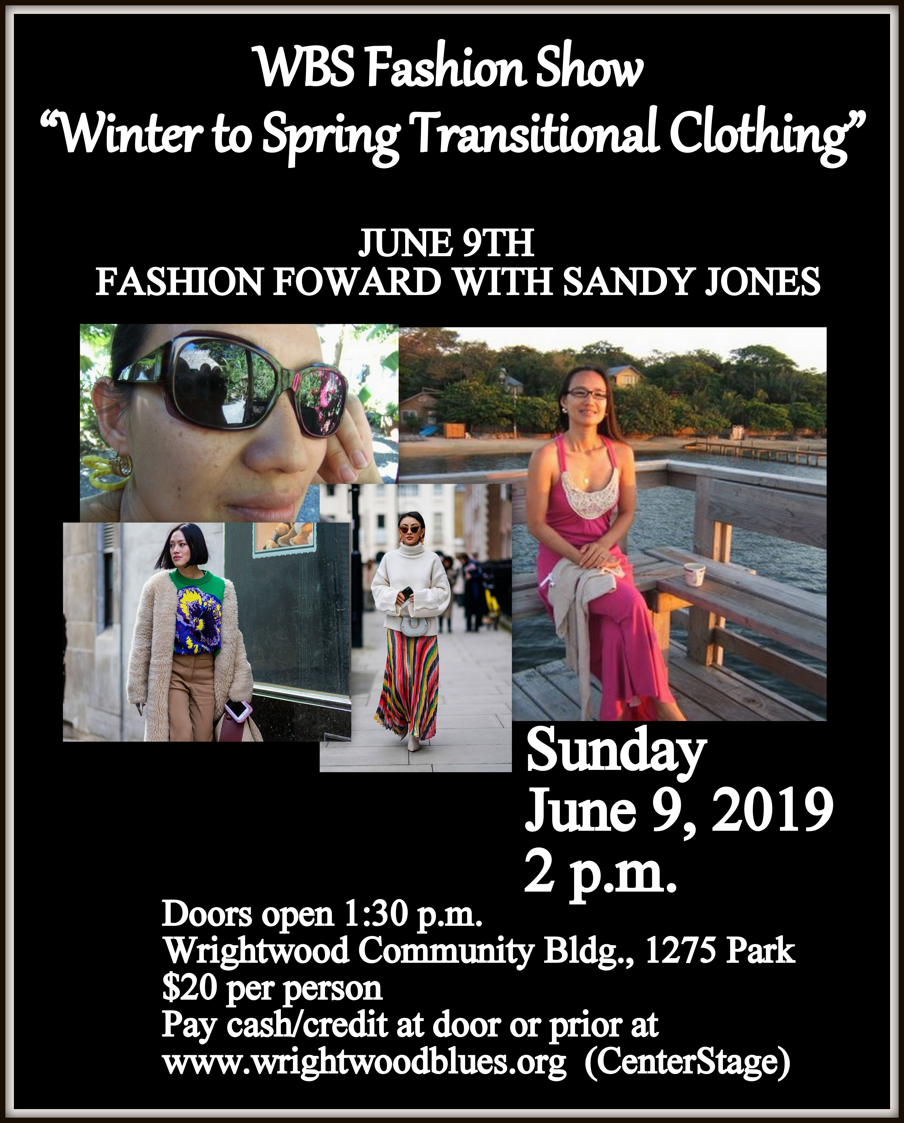June 9  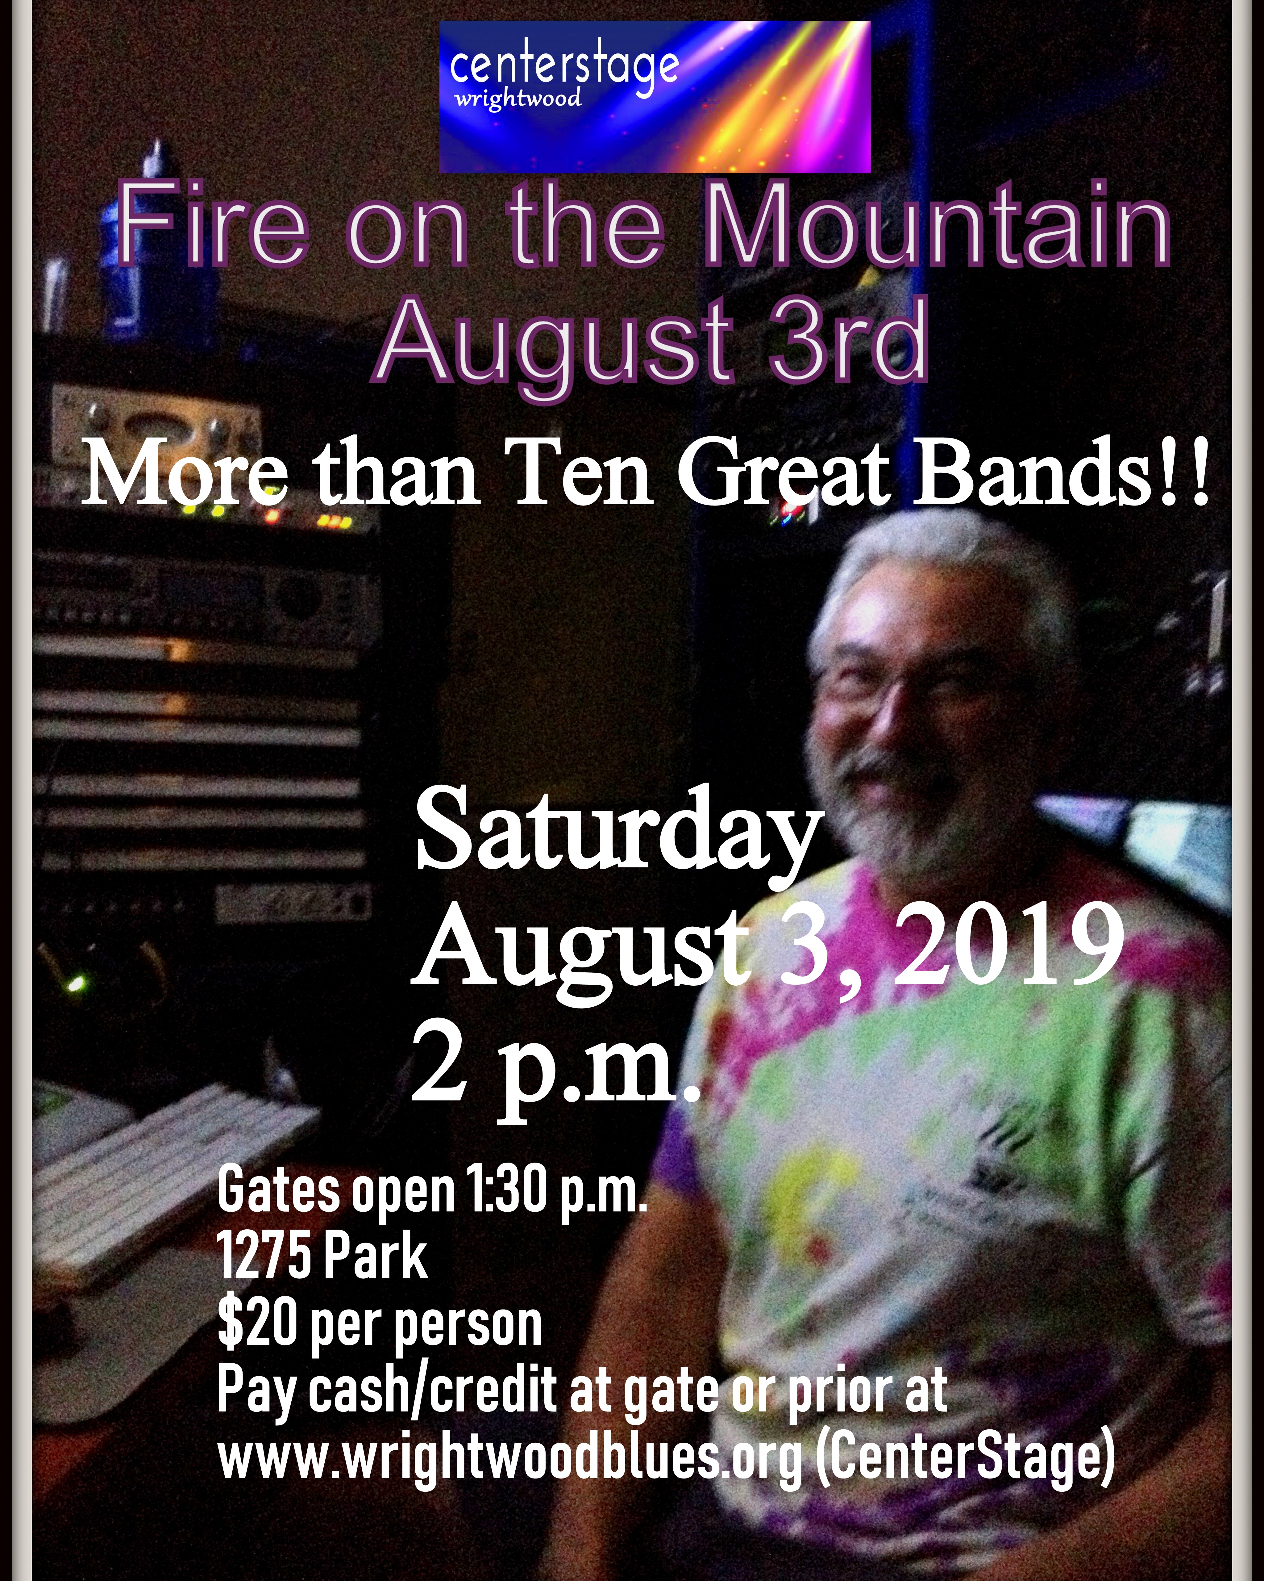August 3  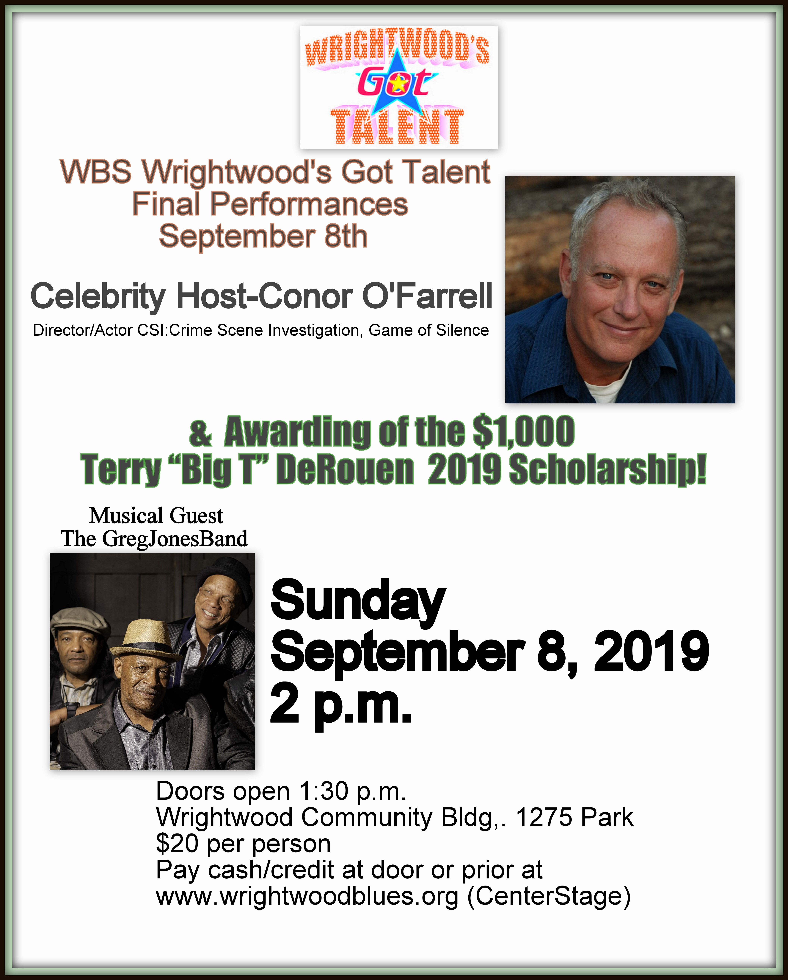September 8 | Okay WBS Members  Here now is your chance to support our year of endeavoring to do our part in making Wrightwood CA the Happiest Place on Earth!  Six Shows, $20 each. ONLY $120 to further the WBS Education, Community Building, Outreach and related causes.  So…SAVE THE DATES …And…BUY THE TICKETS!!! $$$  Even if you can’t attend all six, your donation/gift ensures the success of this series and sends the message that we are on the right track.  Projects underway: 1) Establishing a WW Music/Art Wall of Fame. 2) A Marquee for the Community Building. 3)WW Arts Festival  Tickets Here

