 | You ain’t said nothin’ till you played the blues… |  | January/February 2020
 |  |  | By Dr. Greg Jones
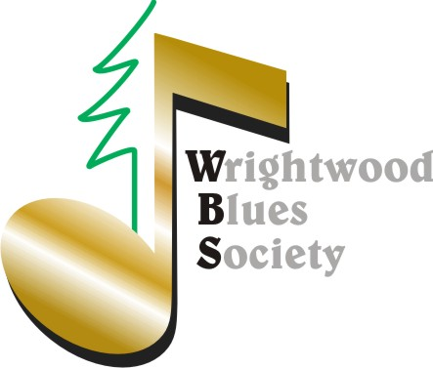 |  | The Davey Ray CD Recording and Show is now in production!  Not to miss shows | SAVE the DATES:  2/15 NSNW Game 3/15 Women’s Shelter Event 4/19 Ky. Arts Spring Concert

Blues Nite Open Mic the First Friday of Every Month 8PM @ the Yodeler Bar & Grill, Wrightwood
“Variety Still the Spice of Life”  The WBS 2019 Christmas Variety Show was awesome. Thanks for supporting that and if you missed, here are a few clips: 2019 Christmas Show  Take a step back in time and enjoy the 'The Not-So-Newlywed Game, featuring four couples who will compete to win a cash prize for their favorite charity based on this popular 1970's game show. The adult-themed evening includes live music (various singers accompanied by Rodger Whitten) and is hosted by Actor and Arts Education Advocate Conor O'Farrell who has appeared in popular shows such as CSI: Crime Scene Investigation and Game of Silence. Valentine's Day also marks the launch of the WBS 2020 membership drive & continuing our music scholarship |  | …fundraising. Featured Celebrity Couples & Charities are: Gayle & Tommy Dowling: Serrano HS Show Choir, Jan and Bob Vondra: Childhood Leukemia Foundation, Jan and Gary Thornhill: Wrightwood Arts Council, Christina and Sean Vivirito: Open Door-Family Assistance Program.  Doors open at 5 p.m. The show begins at 6 p.m. Admission includes dinner and dessert by Sandy Jones: $30 general public admission, WBS members $20, Gold & Lifetime WBS members $10. Tickets online by February 12 at WBS NSNW Tickets!  “Following the Money”  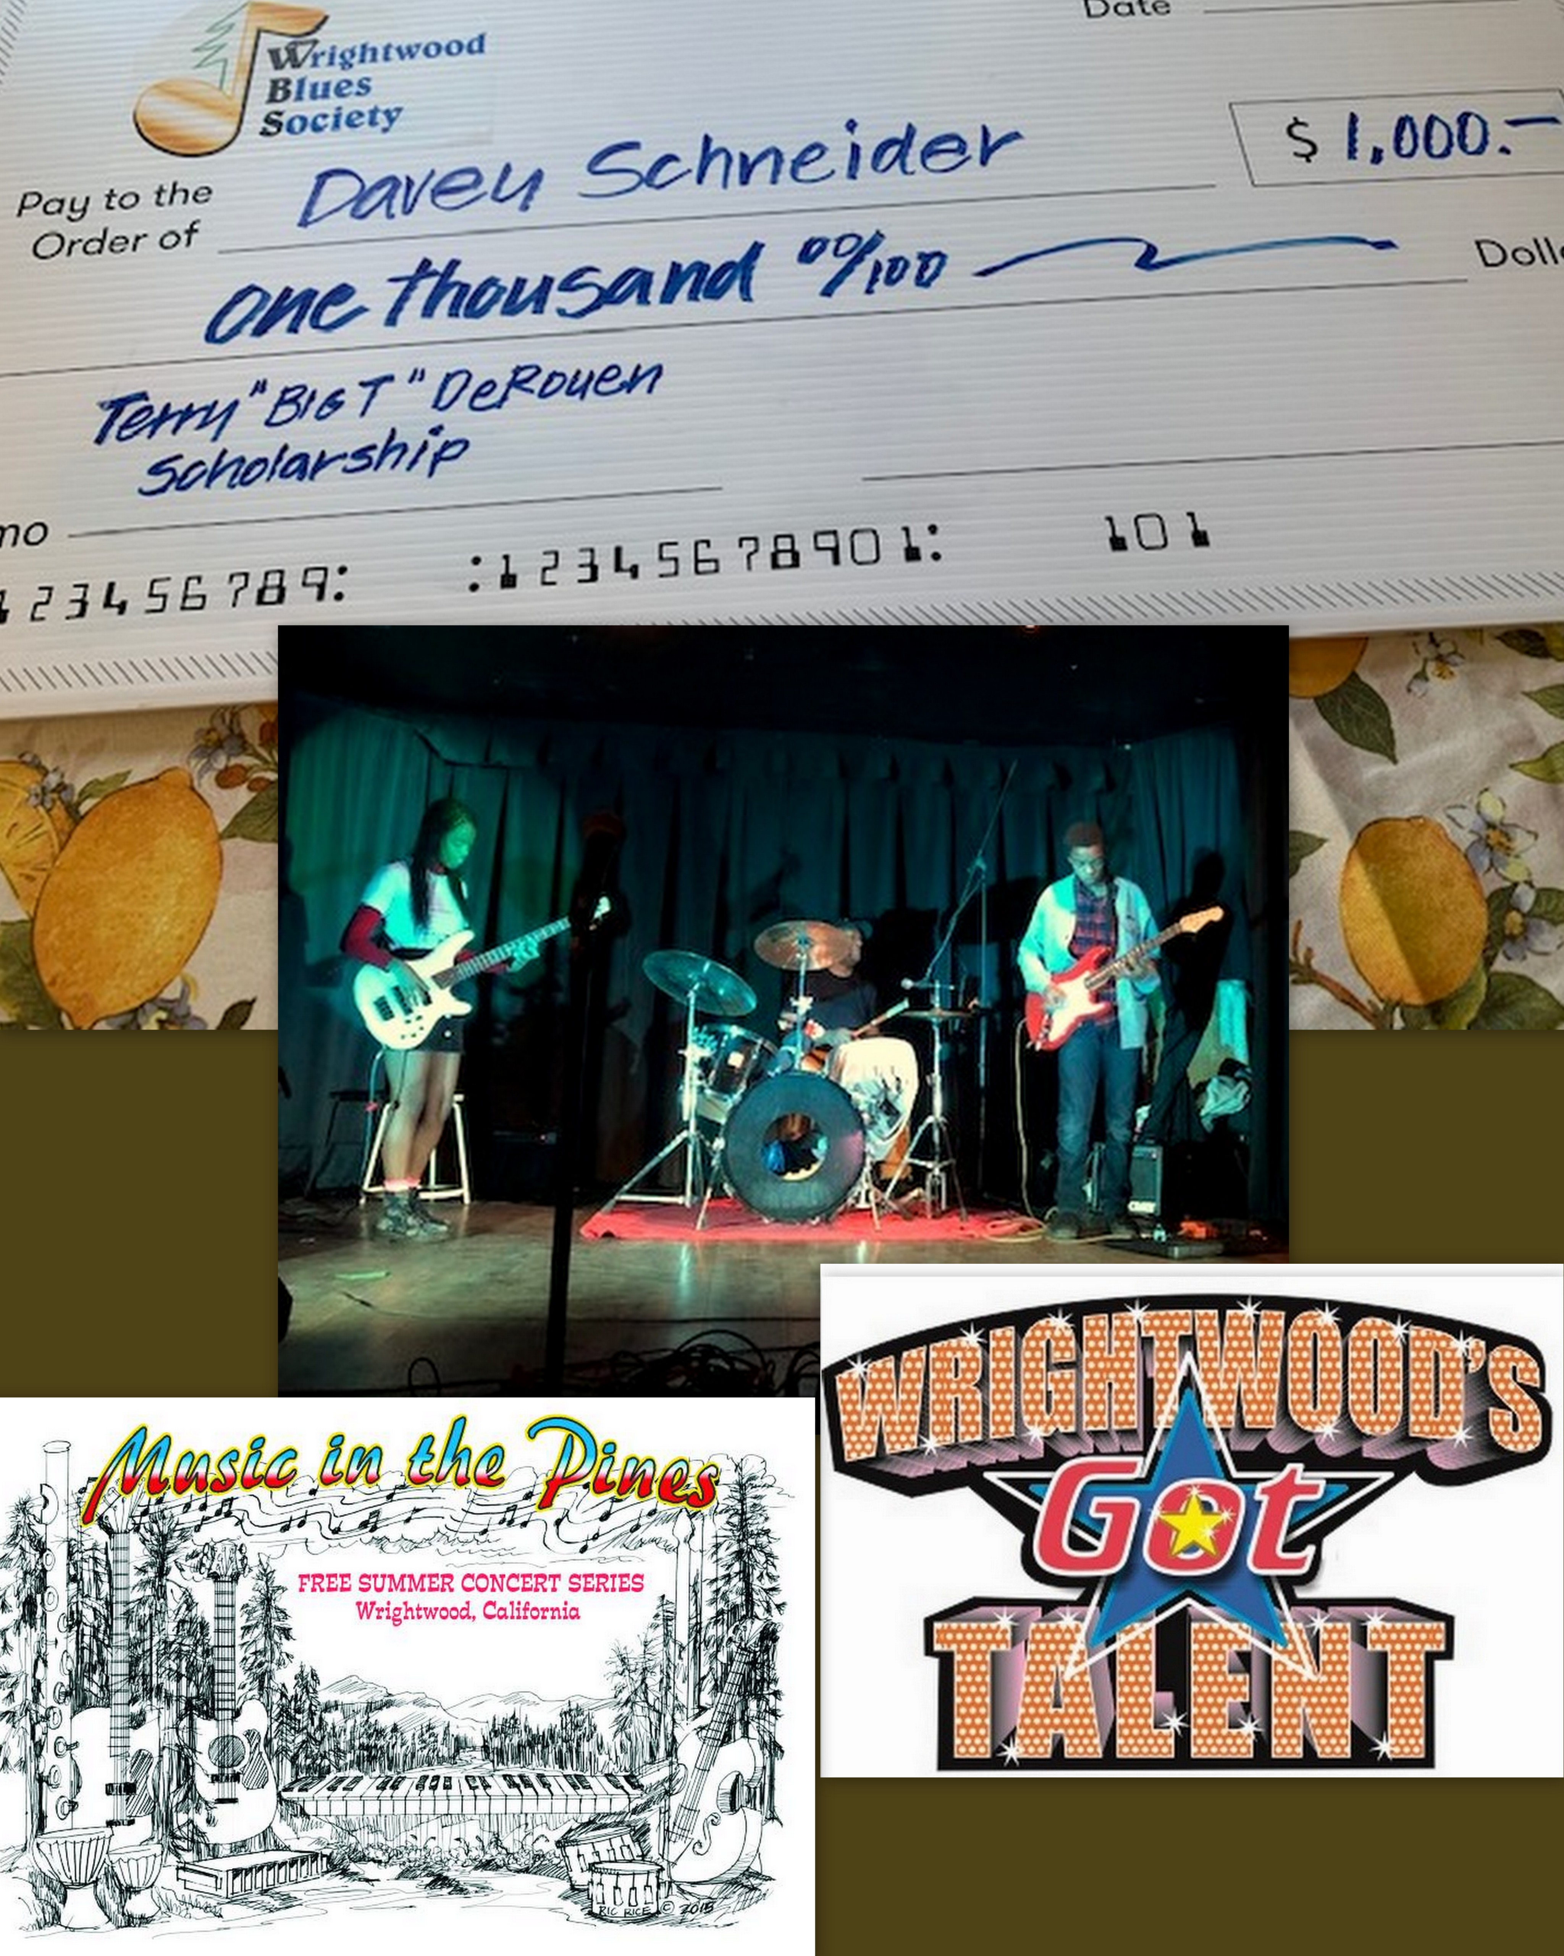As promised, we will follow up with 2019 WGT winners by fostering a paid performance at Music n’ Pines opening June 25th. The goal is to provide these aspiring artist with authentic music business from production to performance exposing all the marketing elements in-between. Stay-tuned. WBS will also support Blues and Folk music at the 1st annual Wrightwood Arts & Wine Festival. | Blues Nite Open Mic  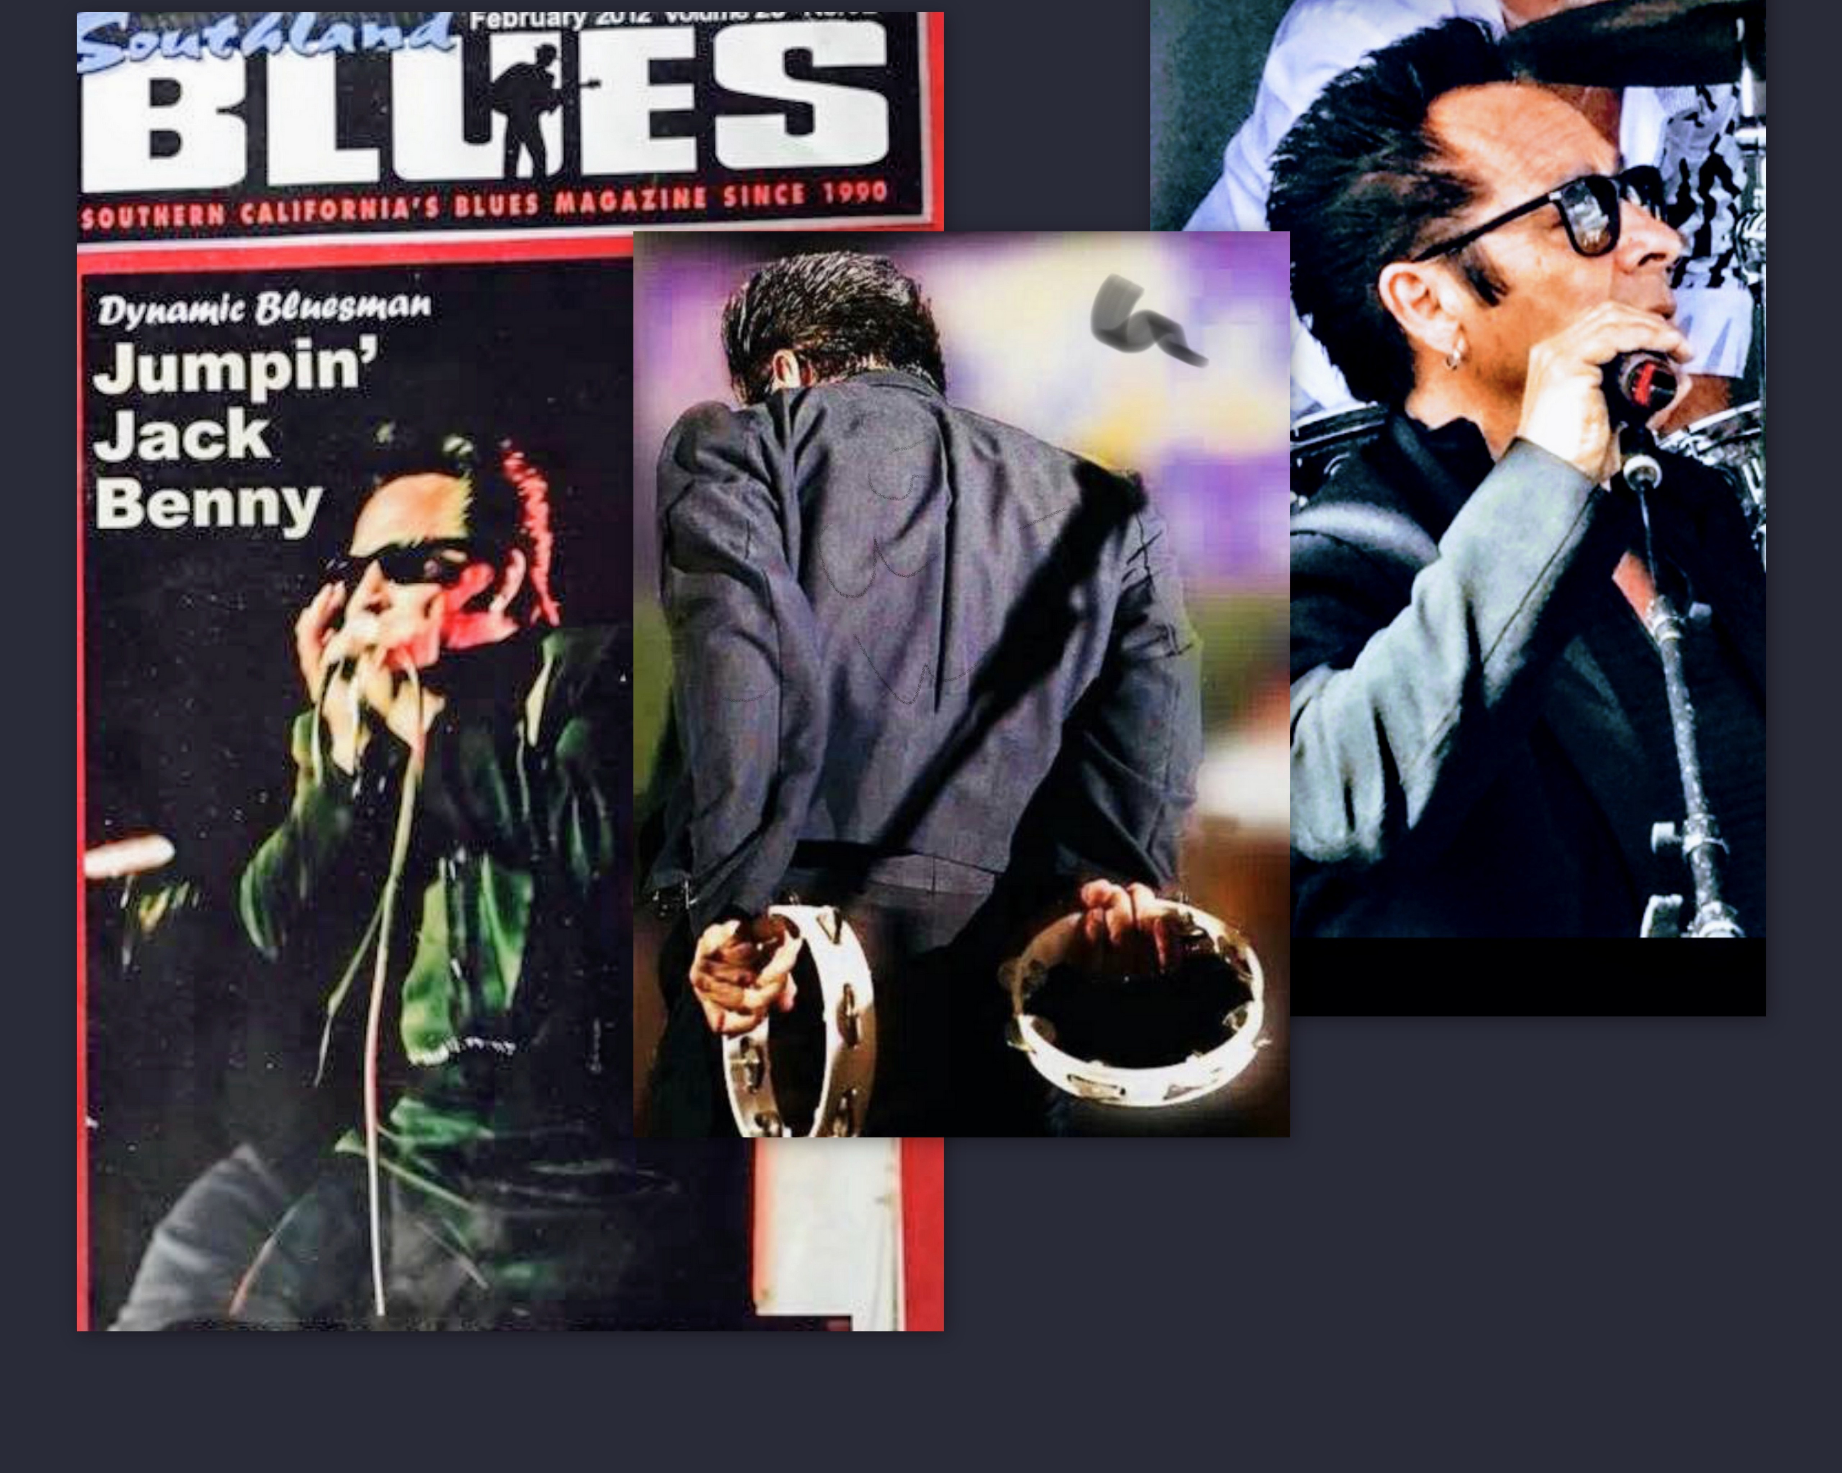(Jumpin’ Jack) Benny Cortez  February 7th  2020 Blues Nites will spotlight the occasional superstar special guest…  March 6th  Pammy Armstrong  …and WBS will co-sponsor an all-star Blues Review opening Music-in-the-Pines June 25th!  Thank you for your 2020 Support!!!!!!!!

