 | You ain’t said nothin’ till you played the blues |  | January 2019
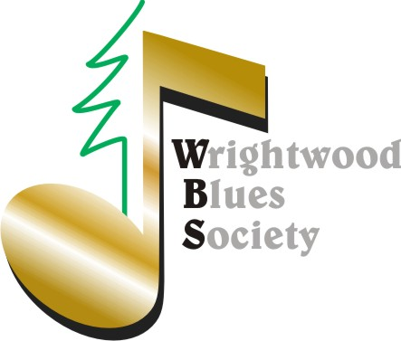 |  |  | In 1992, Terry /Big T recorded “Hold On “with Lowell Fulson: https://www.youtube.com/watch?v=fC-fu_GTmuQ

WBS & PARTNERS TAKE CENTER STAGE
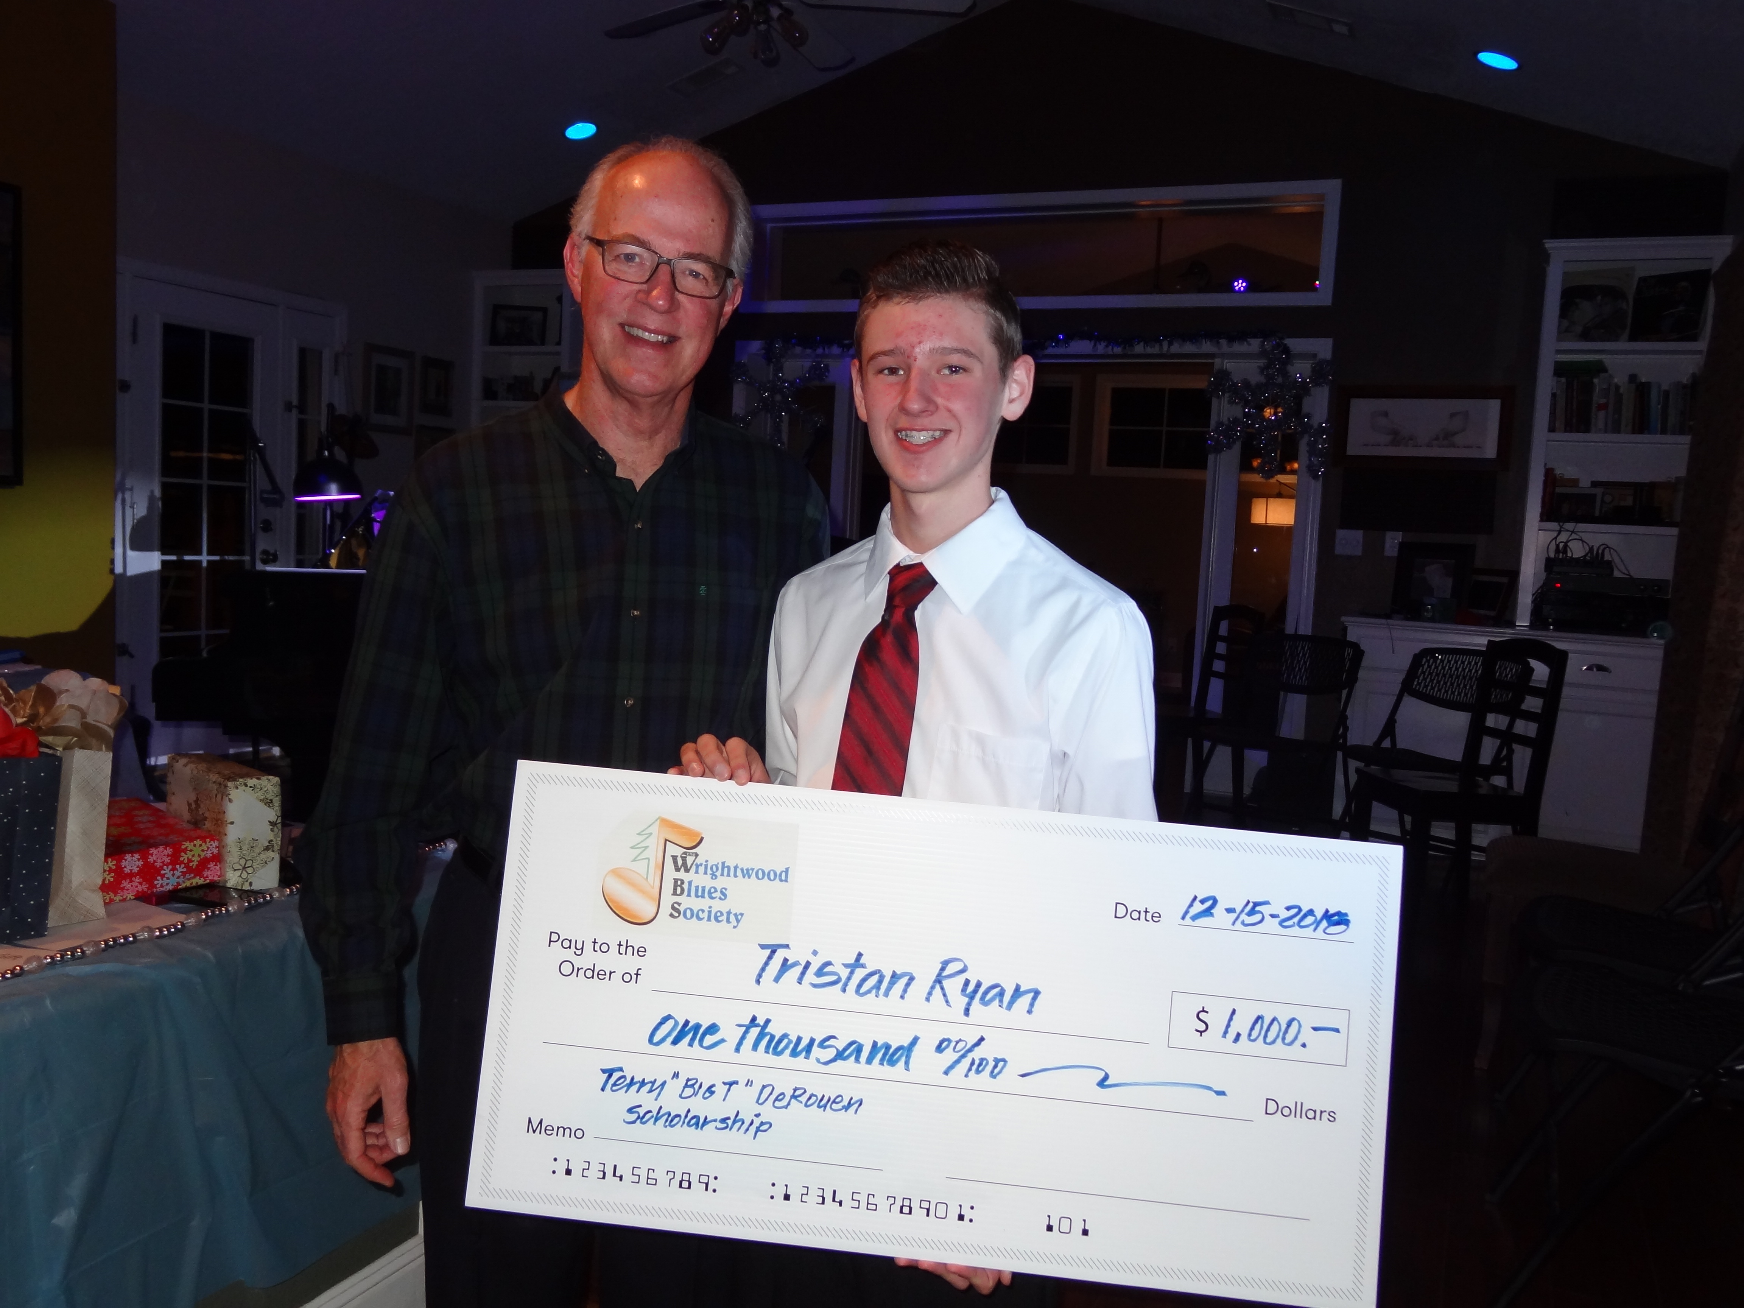 Many thanks to all of you for making the 2018 “Big T” scholarship a success. We will keep you updated on the careers of Tristen and Lincoln. We also caught the attention of Assemblyman Tom Lackey’s office who will recognize our 2018 winners at the March 31st CENTER STAGE**  This year we will again award a $1,000 first place, $250 second place, and certificates of achievement to all participants. The “Big T” award program will take the shape of a “Wrightwood’s Got Talent (WGT) show. Application Deadline: March 30th. First Performance (Preliminaries): April 14th Second Performance (Finals): September 8th. Categories: Dance, Music, Comedy, Visual Arts. Open to all K-12 students in the Keyboard Arts, Snowline, West Palms Conservatory and Victor Elementary School Districts. The fundraising performances will take place at the Wrightwood Community Building. Here is a CENTER STAGE promo for the year: https://youtu.be/40N2p6xfa4k Hope to see you there! |  | WBS has outgrown the Jones Chateau and will work in concert with others to produce and promote a CenterStage** Performance Series @ The Wrightwood Community Building. March 10, 2PM "Bodie Mountain Express" March 31, 2PM "Paradise Camp Fire Fundraiser" w Gayle Live. April 14, 2PM WBS-"Wrightwood's Got Talent." June 9, PM WBS Fashion Show w Sandy Jones. August 3- "Fire On the Mountain" w Tommy Tech Studios. September 8 – 2PM WBS Wrightwood's Got Talent (Finals) We are continuing to add more shows this year. For more information visit https://www.mountainmusic.net/ https://www.wrightwoodarts.com  Oh, …and for MEMBERS ONLY…You’ll be invited to a couple of off-the-record shows at the Chateau!! Stay tuned.  It’s been called “The Best Open Mic in San Bernardino County”  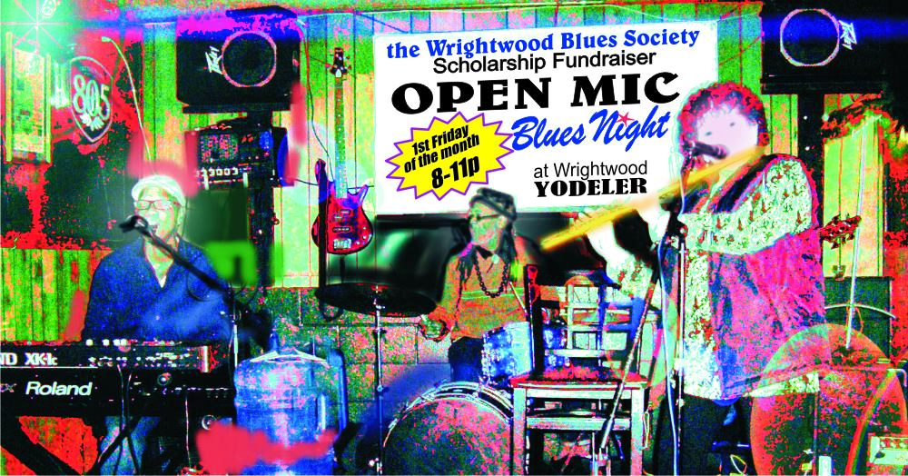 “Like Us” Photo by Ric Rice  https://www.facebook.com/The-Wrightwood-Blues-Society-2111613472240001/ | 1st Friday of Every Month At The Yodeler  What makes our Open Mic Special? Three things. Talent, Purpose and Opportunity. Talent: We provide a capable, cohesive house band to start things off and excellent backing for anyone to perform in front of. Purpose: While we ensure a good time is had by all, we also ensure every dollar in the tip jar serves the WBS mission. Opportunity: I learned a long time ago that what most folks want is an occasion, encouragement and even permission, to do something out of the ordinary. Even seasoned musicians show up to try out new material when the vibe is right. And that’s the secret. We don’t judge, we applaud. So don’t hold back. Sing, play, dance, slam poetry or even do 2 minutes of standup!!! Just remember, you said nothing, till you played the blues. -Greg

