 | You ain’t said nothin’ till you played the blues… |  | July 2019
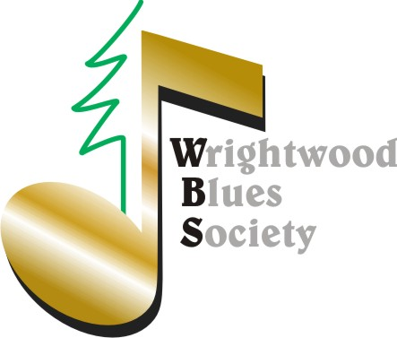 |  | Congratulations to our newest lifetime member…Dave Fox!!  Music Concerts for Members | SAVE WBS DATES: *Members Only Events  *10/26 Masquerade Party  *12/21 Xmas Party  *9/8 Scholarship Award

Spreading the Love!
High Desert Keepers (HDK) Success  Thanks for helping us raise $400 and augment awareness of HDK and the work they do for us all. Let’s keep them in our hearts: https://www.highdesertkeepers.org/  Arizona Blues Run  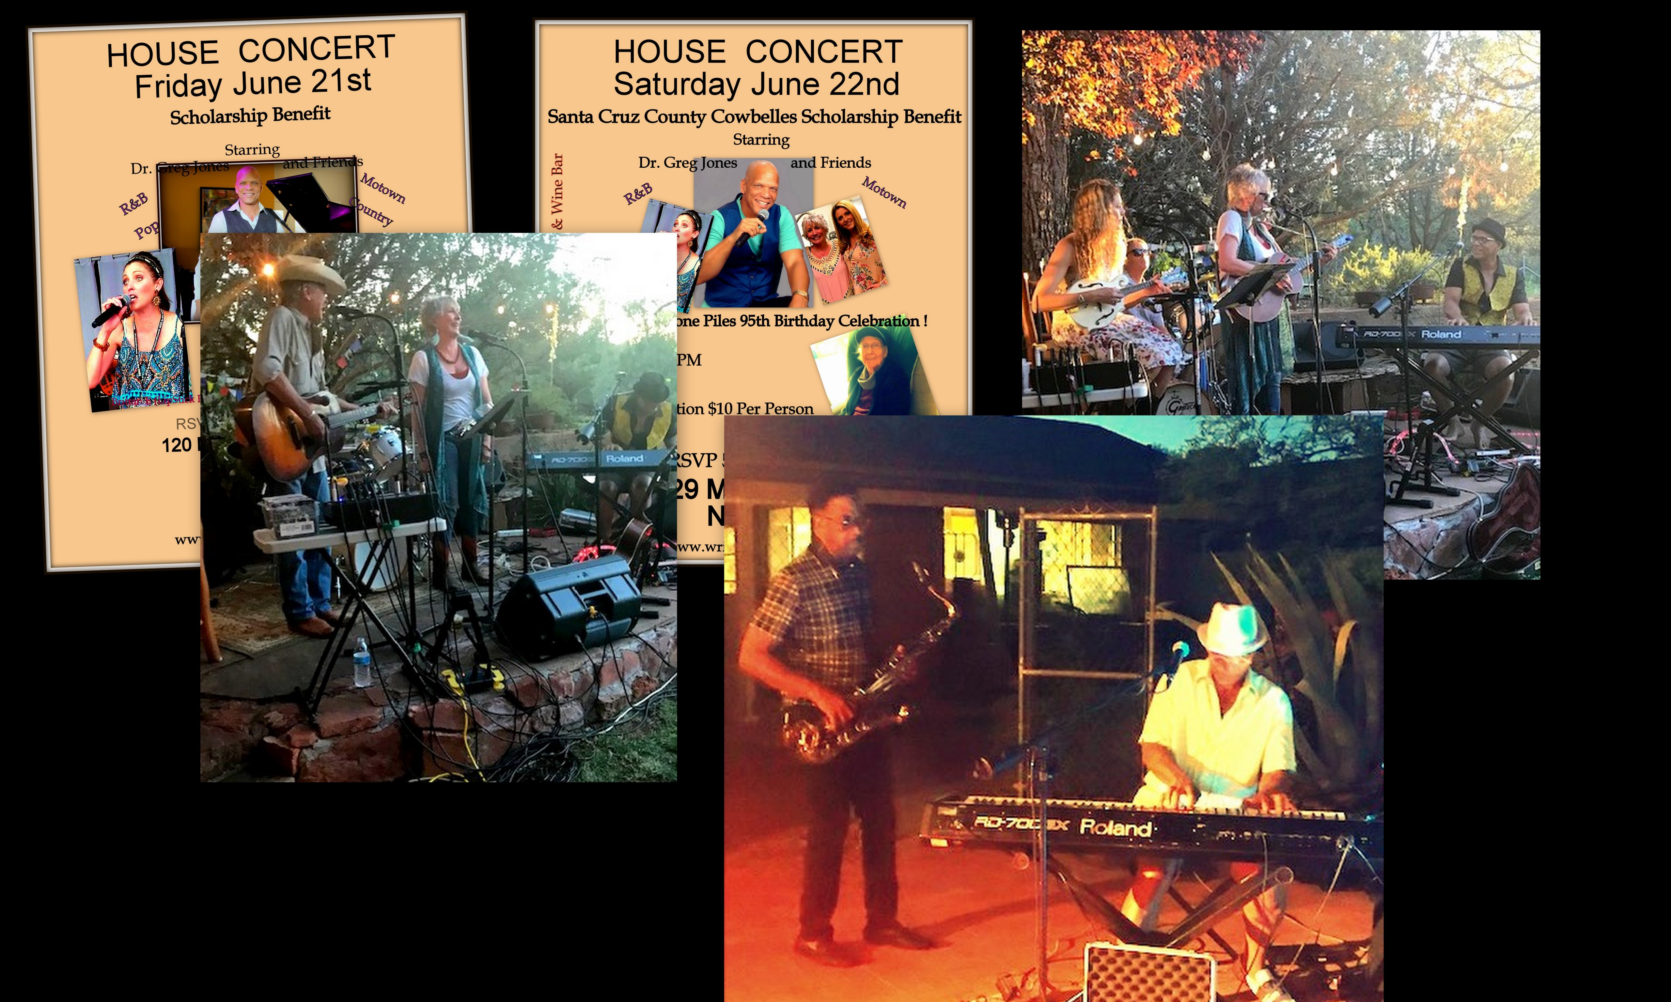  Thanks to WBS Members Diana Piles and George Keen for hosting events in Sedona and Nogales which raised scholarship funds for WBS and the local Cowbelles. We shall return to Arizona and… Any WBS member wanting to host an event should keep our roadshow ability in mind!  June 29th Members Event… |  | … was really quite the top-notch, unrivaled  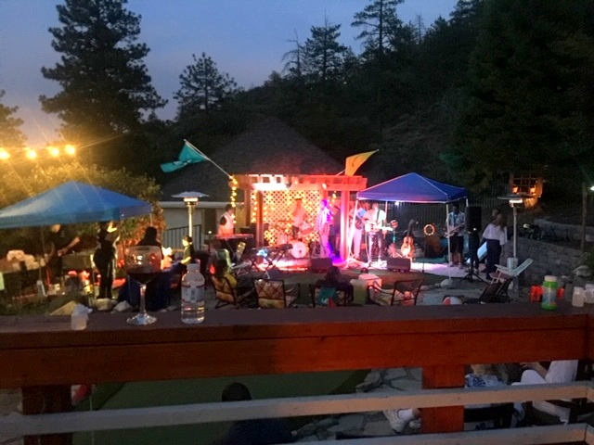and extraordinary  from music to food to sound, lighting & gregariousness event…raising funds and sending the WBS President happily into retirement. More pics at: https://www.wrightwoodblues.org/gallery/  What is Fire on the Mountain (FOM)? The 12 year brainchild of Member’s Tommy & Gayle Dowling. WBS has proposed FOM become the music portion of a 2020 Wrightwood Arts Festival. Stay tuned…more importantly-Show Up early 8/3 for our Wall of Fame induction! Save on advanced Tickets: Here  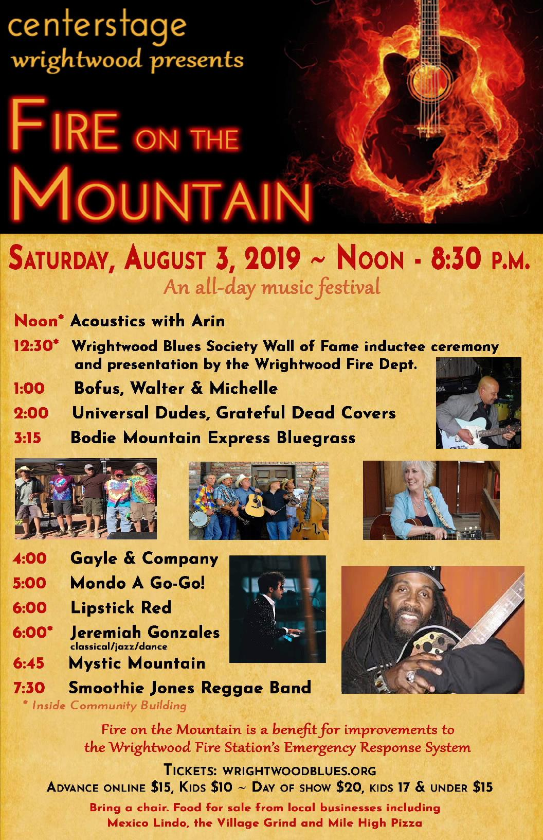 **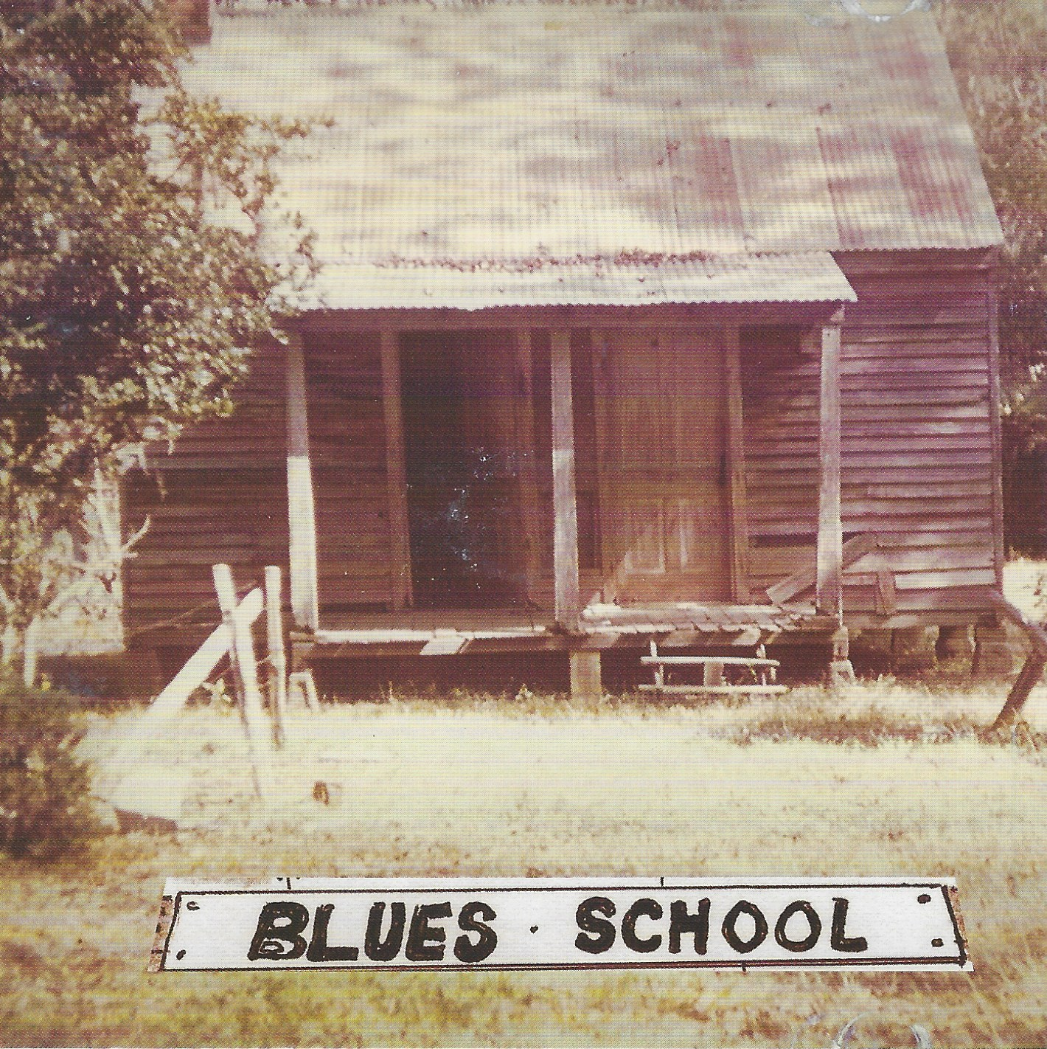 | What is “The Blues?”  The Answer  Click  We are going to throw WGT Finalist a challenge in keeping with our WBS mission, One of the judging catagories will be their Blues-Relatedness.  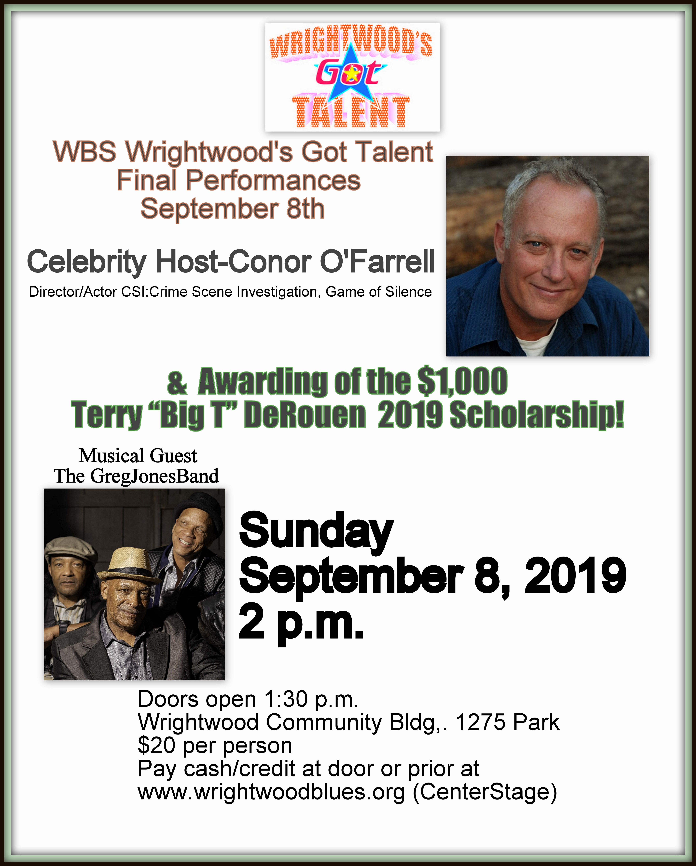  A "Blues School" performance assistance day is scheduled for SundayAugust 25th  **Cover pic from Big T’s CD featuring childhood home.  Speaking of roadshows: Watch Idyllwild

