 | You ain’t said nothin’ till you played the blues… |  | May 2019
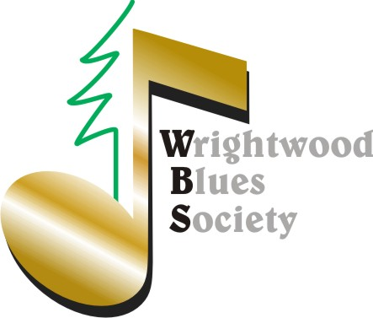 |  | 3 Free Music Concerts for Members Only | SAVE WBS DATES: Members Only Events  *June 29 Greg Jones Retirement Party  *October 26 Masquerade P Party  *December 21 Xmas Party

Membership Renewal Time!
Wow! What an amazing first year thanks to you. We hope you agree that what we have accomplished together is…well exactly what we hoped we would!  - A more cooperative approach to scheduling events.  - Partnerships like CenterStage Productions that raise our local sound, lighting & venue bar.  - Performances that promote social activism while facilitating charitable contributions.  - A monthly Gathering/Blues Night dubbed the best open mic in San Bernardino County.  - A meaningful scholarship program.  - Continued bragging rights as the coolest membership in town.  Effective (& retroactive to) December 19, 2017, WBS is classified as a public charity and all donations and … |  | …contributions are tax deductible under IRC Section 170. Treasurer Janine has informed me that renewal notices will begin going out this month…so please take action and keep the party going. You can renew (and others can join) here: WBS Store Whether you are a Regular, Plus, Gold or Lifetime, you are Member of the family in good standing! Speaking of which, welcome New Board Member: Terry Bottorff!  FASHION FORWARD! A fundraiser for High Desert Keepers (HDK) Hosted by Sandy Jones, the goal is to recognize and honor HDK volunteers. Wear an outfit that expresses you and you’re in the show!  Door prizes and fashion expression prizes will be awarded. Live music will be included to compliment the "self-expressions," and refreshments will be offered by the Village Grind.  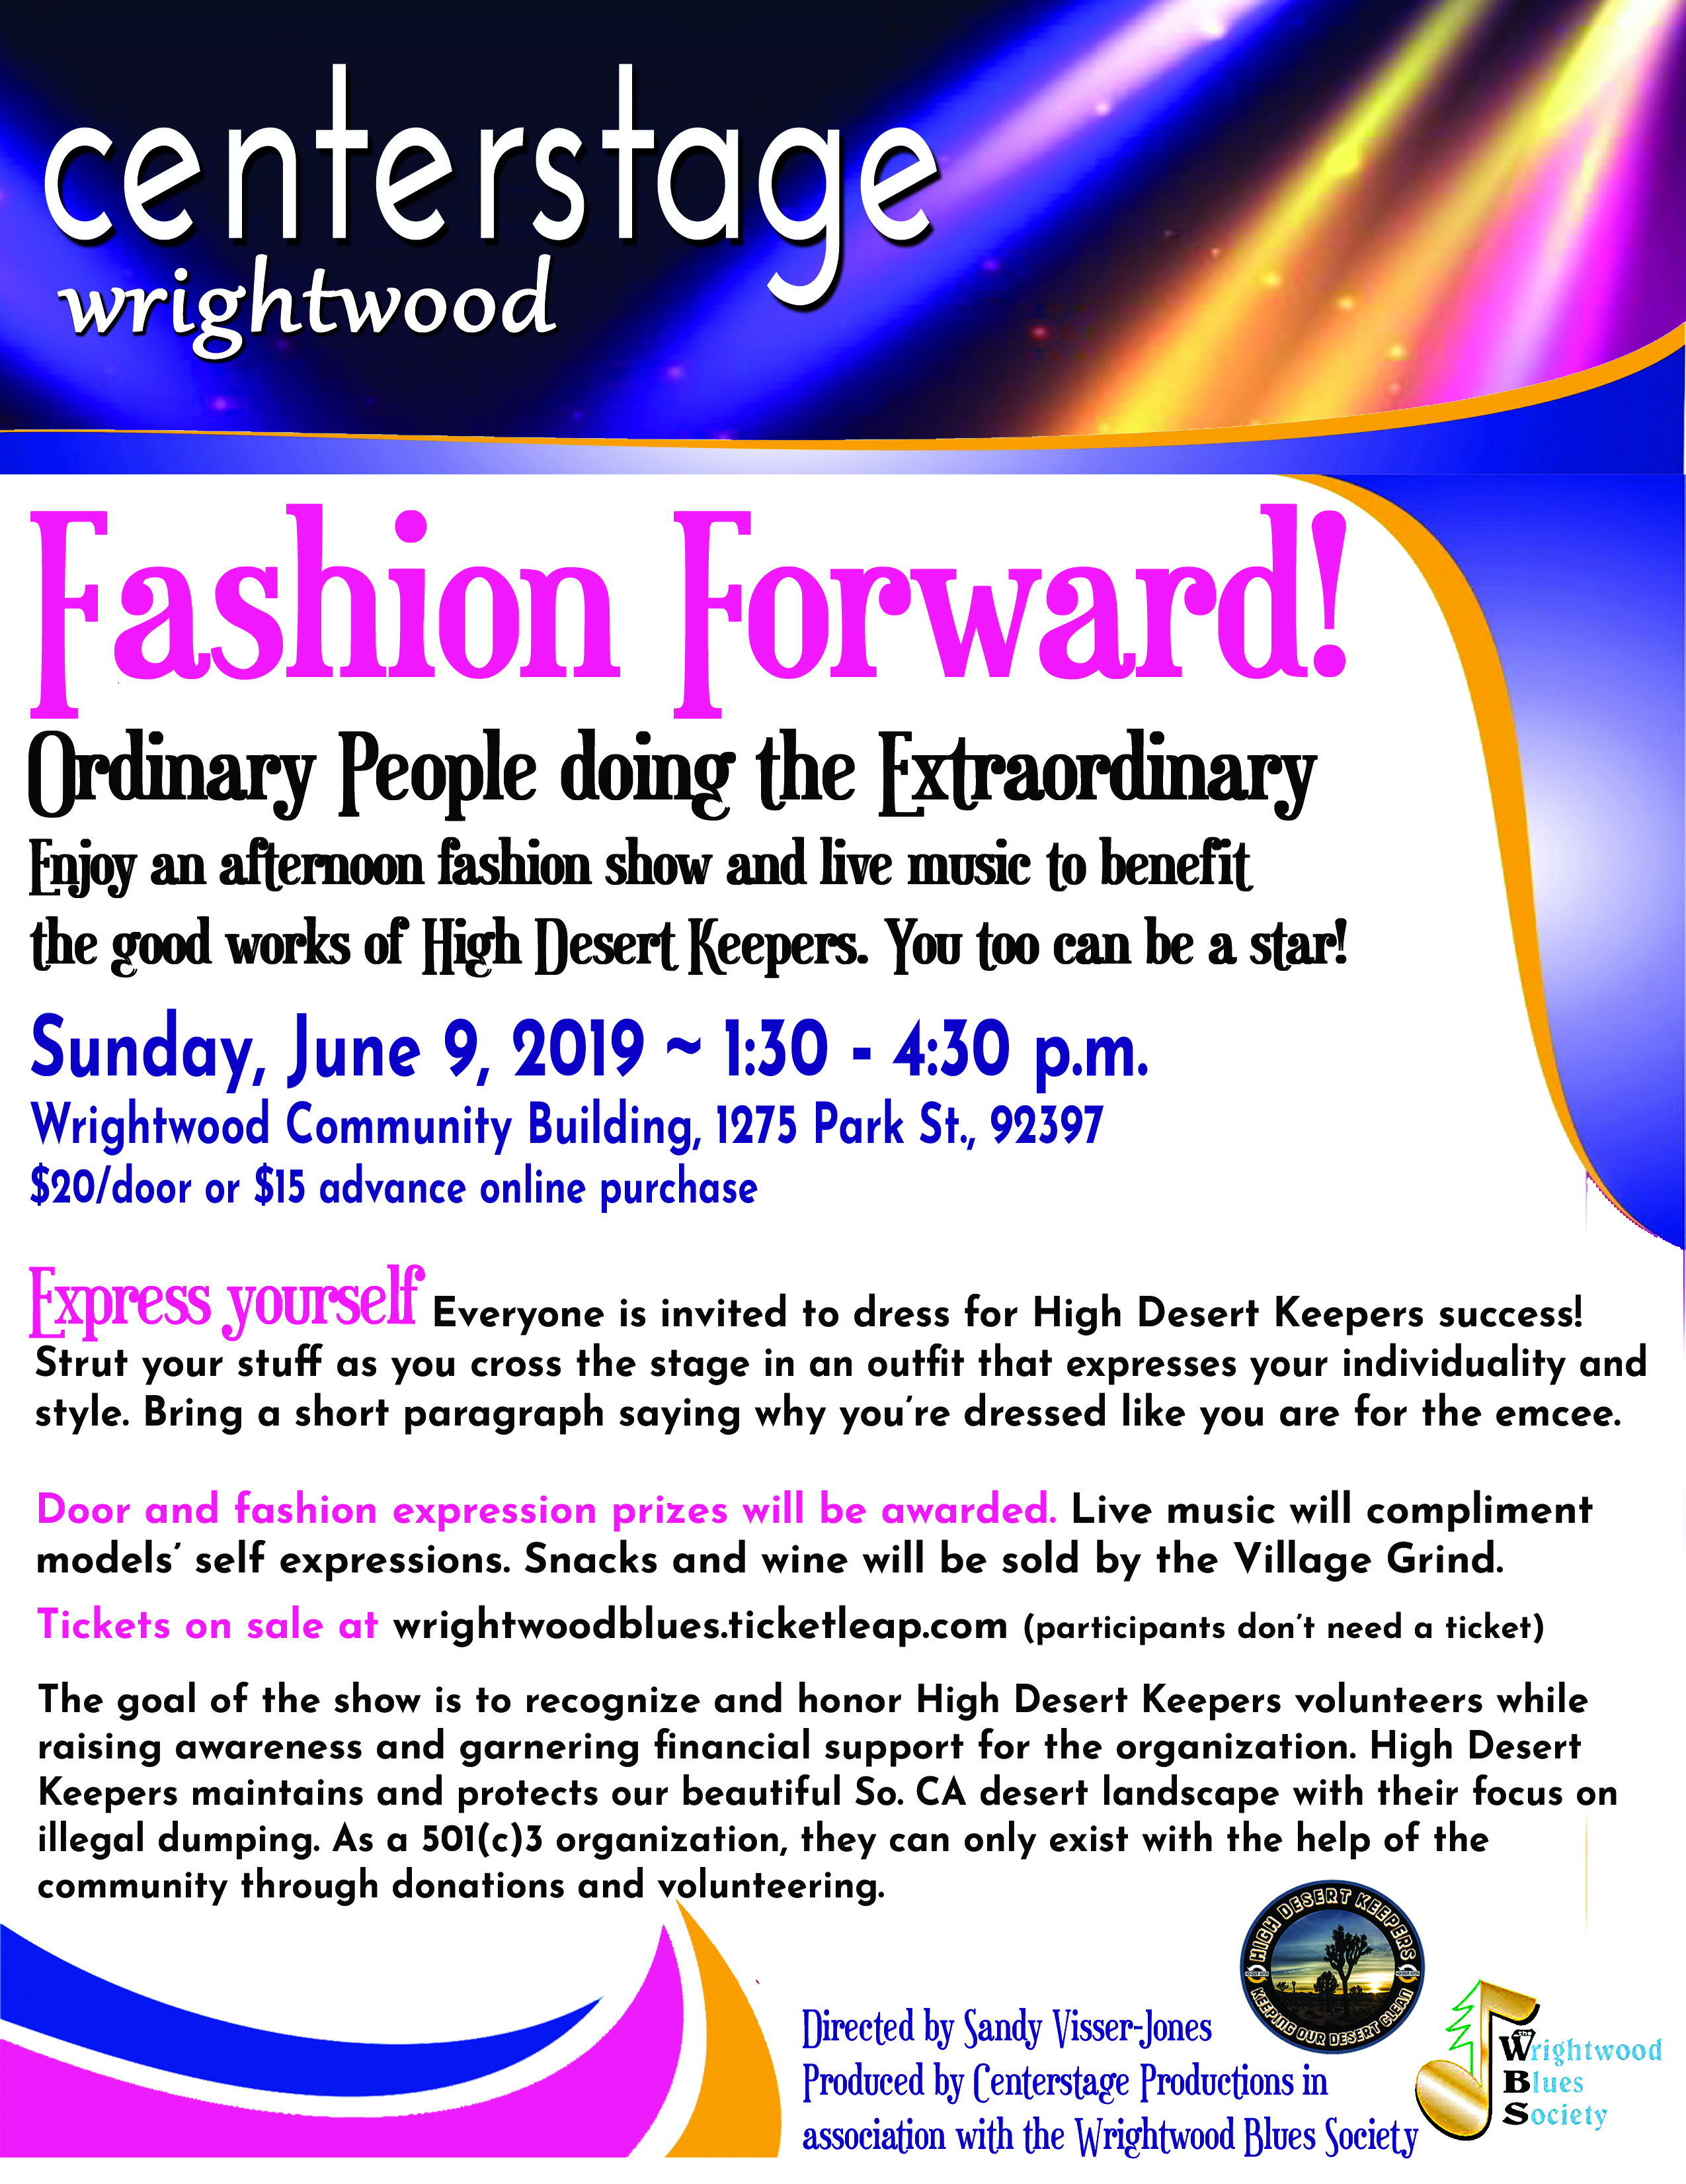 | Wrightwood Wall of Fame  Congratulations to Lora Steinman and John Burcher for being selected as Wrightwood’s first Wall of Fame inductees !  Two more inductees will announced at the June 9th Fashion Forward  Inductees will be officially honored at the Fire on the Mountain music festival, Saturday August 3rd.  Tickets and information:  Fire on Mountain Music Festival

