 | You ain’t said nothin’ till you played the blues |  | November 2018
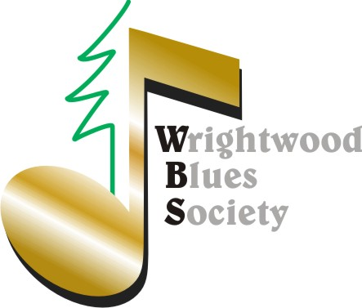 |  |  | WBS Presents *Blues Night Open Mic *First Friday of Every Month *@ The Yodeler. Hope to see you there.

RIP Big T. Your Legacy of Love Lives on in Our Hearts, Your Music and the WBS Terry “Big T” DeRouen Scholarship!!!
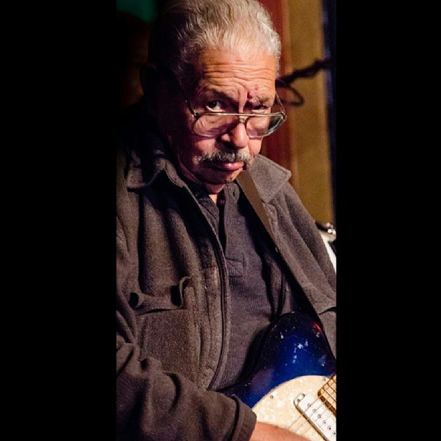 Many thanks to all who were able to support Karen at the “T” Tribute show. We did him proud.  The scholarship applications will be in the hands of the judges in a few days. Time to start planning the 2018 Christmas Show, at which time we will present the award. Contact us with any ideas. If fact, contact us with any ideas about anything! WBS belongs to its members so feel free to steer. The WBS Board meets the first Friday of every month and Members are welcome. 5343 Shirley J Lane.  The board has elected to scratch the limited enrollment period so new members are being accepted.  Welcome New Members: Joan, Denise, Linda, Shirah and new treasurer Janine. Janine also provides leadership for Friends of the Library. |  | New Partners: The Wrightwood Arts Center, provides workshops and promotional support in the visual, music, movement, textile, healing, performance and literary arts. Check out the master calendar at: https://www.wrightwoodarts.com  Events this weekend. The Dudes take the Yodeler stage Saturday night. Dancing on the tables is allowed!  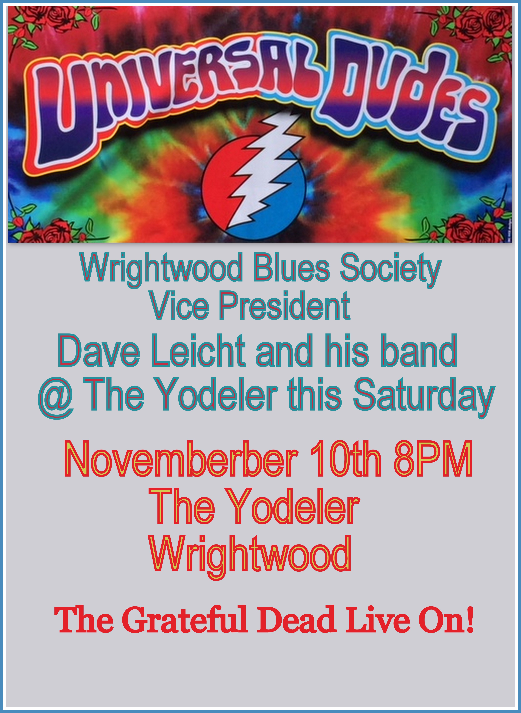 Always a good show.  On Sunday, don’t miss the return of FoJo, at the Grind! A Fun R&B Duo and friends.  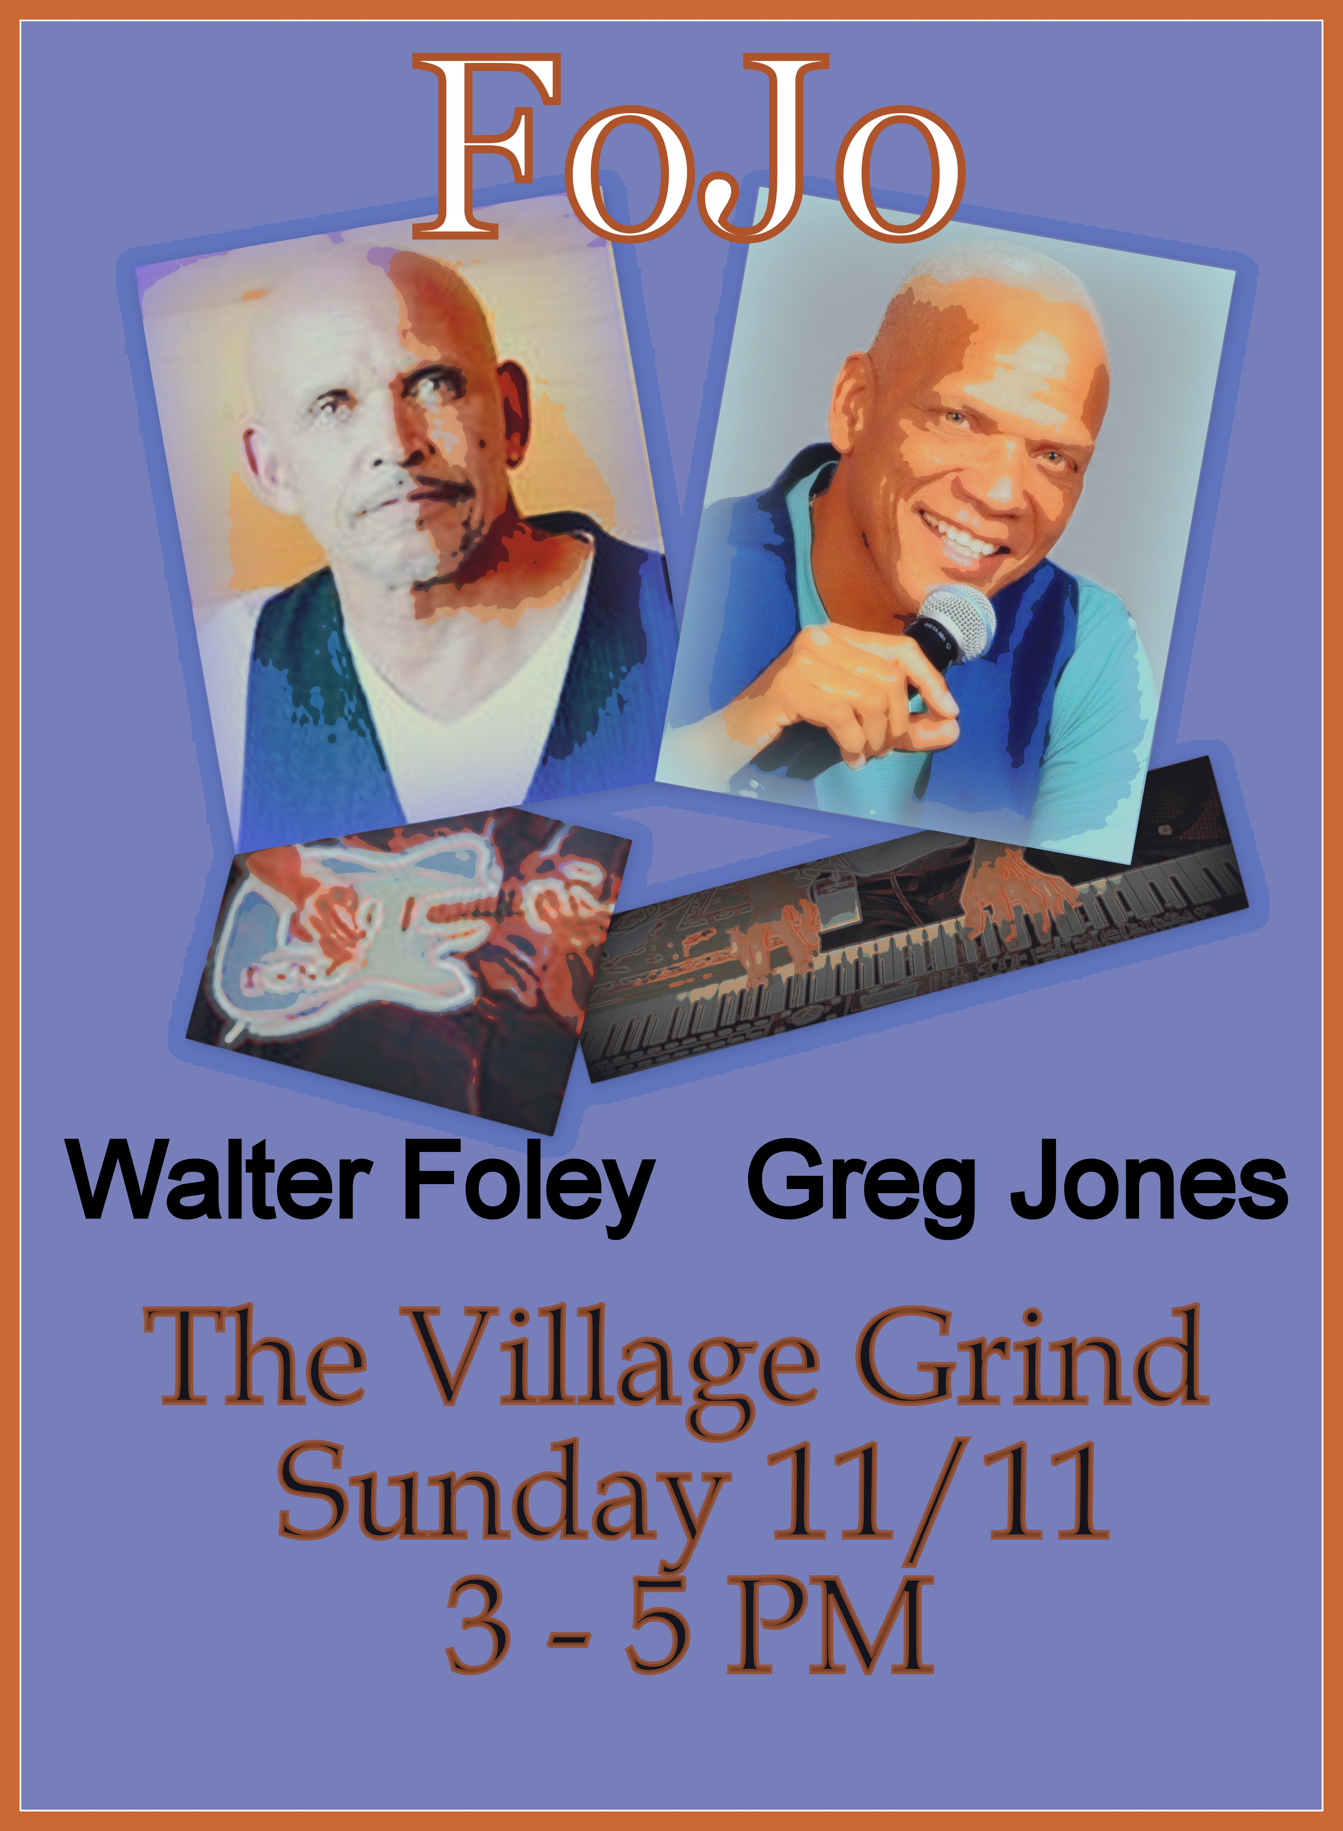 Enjoy great vino on the deck! | Wrightwood’s  got  talent  Following the successful format of Gayle Live, three producers will team up in 2019 to provide a Community Center Concert Series. Ideas being discussed include offering the WBS scholarship in the form of two Wrightwood’s Got Talent shows. Stay tuned for details of this and other unique shows planned for the Community Center.  -Greg

