 | Goodbye Summer Hello Fall |  | September 2018
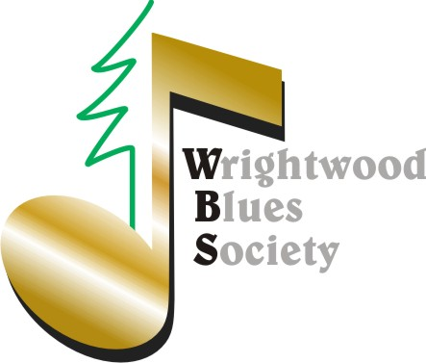 |  |  | WBS Presents *Blues Night Open Mic *First Friday of Every Month *@ The Yodeler Hope to see you there

$1,000 raised for ‘Big-T’ scholarship!
WBS will give away a $1,000 scholarship award during the annual Christmas Performance December 15th at the Jones Chateau. The WBS Scholarship committee (Gold and Lifetime Members) will select from applications submitted by current 1st -12th grade Keyboard Art students http://www.keyboardart.com/  …based on 1) Financial need, 2) A Blues Essay, 3) Extracurricular activities, and 4) A letter of recommendation/Talent. The scholarship is named after Blue’s legend Terry ‘Big T’ Derouen. This is something all WBS Members can take pride in. Thanks You!  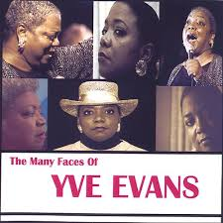 |  | The summer Chuck Alvarez concert was as educational, inspirational and entertaining as advertised. Thanks for all the great feedback. Check out the pictures here: https://www.wrightwoodblues.org/gallery/july-14th-2018/  BTW, if you haven’t received your WBS membership gift, you soon will, as Ric continues shipping!  We now look ahead in support of “Gayle Live” September 15th & 16th (you’ll be kicking yourself if you miss it) Keyboard Arts’ ‘Jazz n Cheese’ September 22nd and the Wrightwood Literary Festival September 29th-30th https://www.wrightwoodlitfest.com/  WBS will begin search for a new treasurer as outgoing treasurer and arguably one of Wrightwood’s most valuable players, Dianna, relocates to Arizona! We can’t thank Dianna and Larry enough for their friendship.  Yve Evans and the Ron Kobayashi Trio (Save the date: October 13th)  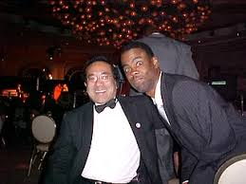 | October 13 will be Show of Shows  Not one, but TWO world class acts share the Chateau stage October 13th. The incomparable Yve Evans who performed here in 2015 will return, but instead of playing piano, she will be backed by the Ron Kobayashi Trio. This was actually a booking error in that I put feelers out to both acts and both simultaneously responded “yes.” You’re welcome -Greg
Yve will make you, laugh, cry, sing, love…. Ron’s drummer, Steve Dixon & are old college
friends. I don’t know why Ron is posing with Chris
Rock, but why not put it here anyway.

